**Experiment No. 1**

**Title:**

Sketch out and analyze architecture of Moodle cloud portal and moodle cloud site and create different entities dynamically.

**Objective:**

To learn Software as service using Free trial of Moodle cloud

**Tools used:**

Internet , Moodle cloud service

**Prerequisite:**

Understanding of Software as service in Service model of cloud computing

**Theory:**

MoodleCloud is a learning environment that is hosted in the cloud. For everyone who requires an online learning environment to conduct a class or promote learning in any setting, including instructors, trainers, and students, MoodleCloud is a good solution.

Since it is in the cloud, as its name suggests, there is no need to download it. As a result, MoodleCloud makes creating your own Moodle site very quick, with little guesswork. It is the hosting system for Moodle, created and managed by the Moodle developers. MoodleCloud is a ready-to-use LMS solution that includes the most popular Moodle functionalities.

After a short and simple setup process, you can start your road toward e-learning distribution with this free or inexpensive hosting solution for a straightforward but fully working Moodle site.

Moodle Cloud is designed for organizations that want to understand what a Moodle site can offer because of its focus on simplicity and speed. It is a straightforward answer. Moodle Cloud should get you up and running if you have fewer users and merely want to quickly and easily provide basic e-learning content to your learners. However, it offers less flexibility that having a self-hosted platform.

**Step 1. - Creating Account For moodle cloud service**

**<https://moodle.com/solutions/moodlecloud/>**

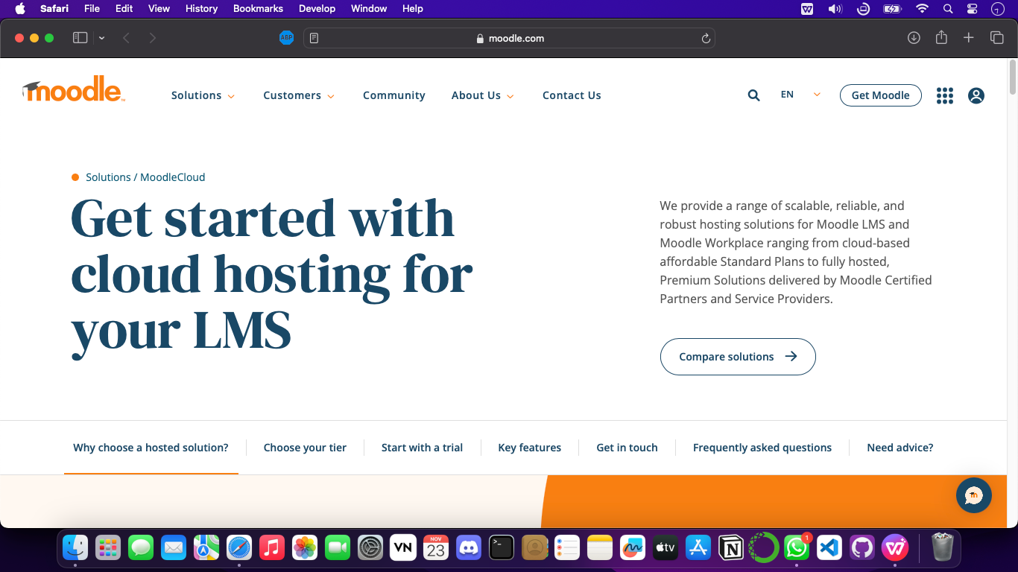

**Step 1. – Enter your details For SignUp <https://moodlecloud.com/app/en/signup/personaldetails?plan=lms_50.0>**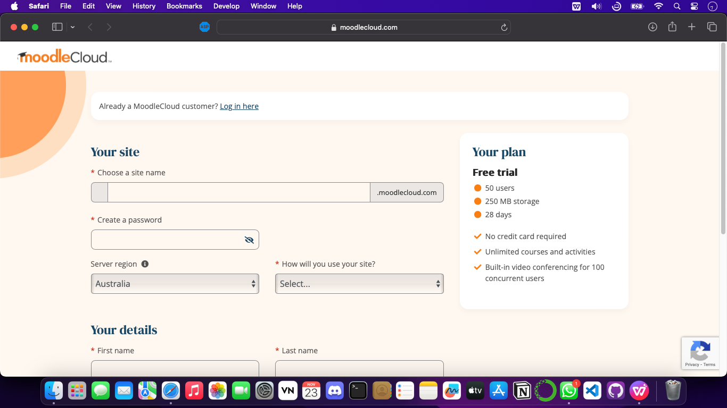

**Step 2 Enter your domain name**

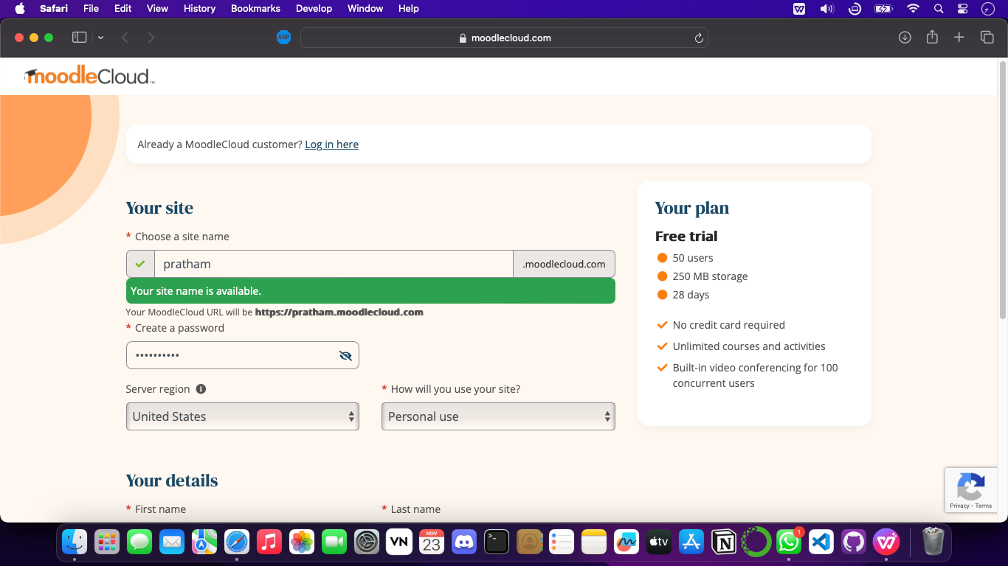

**Step 3 - Enter all details including password, region and accept terms and condition’s**

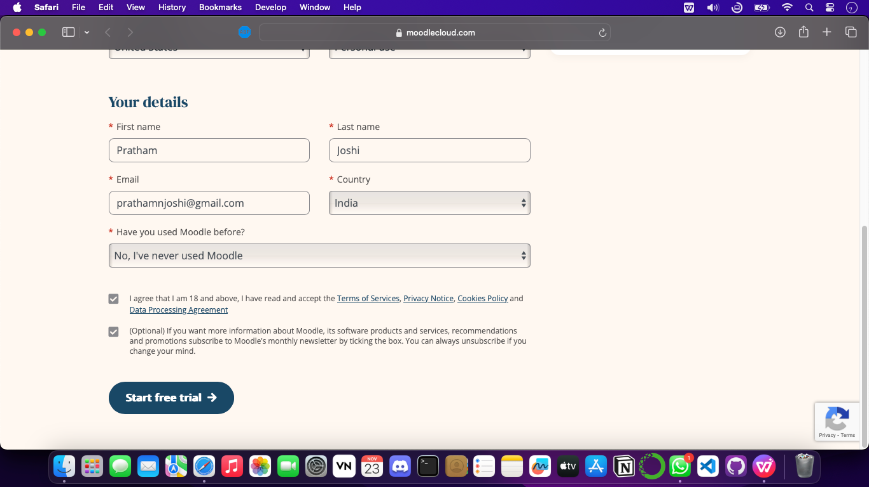

**Click on start Free trial**

**Step 4 - Sucess**

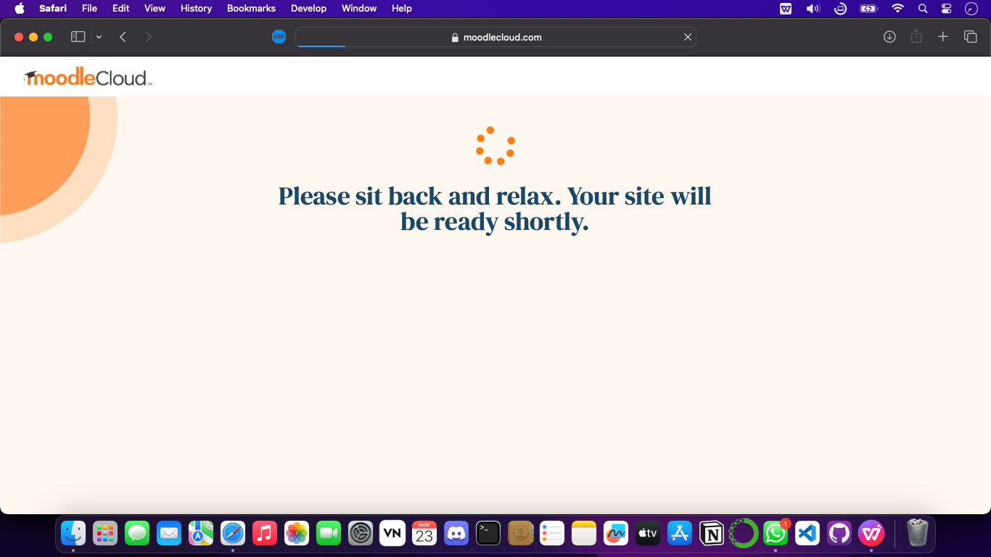

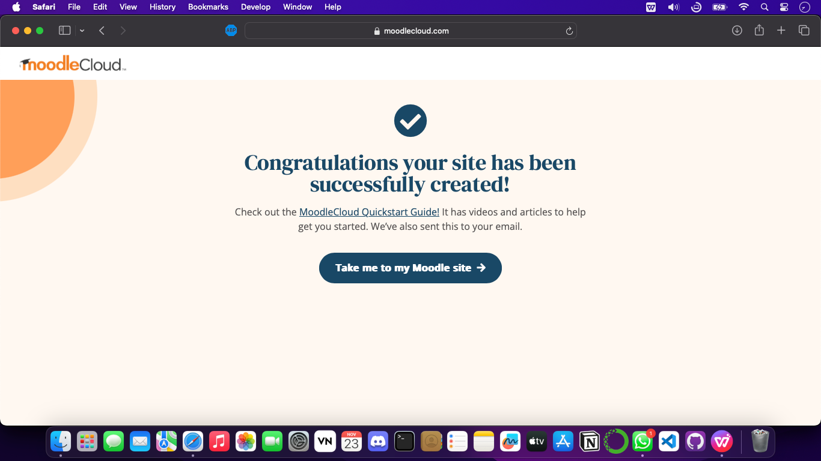

**Step 5 - Get started with creating your first Moodle course**

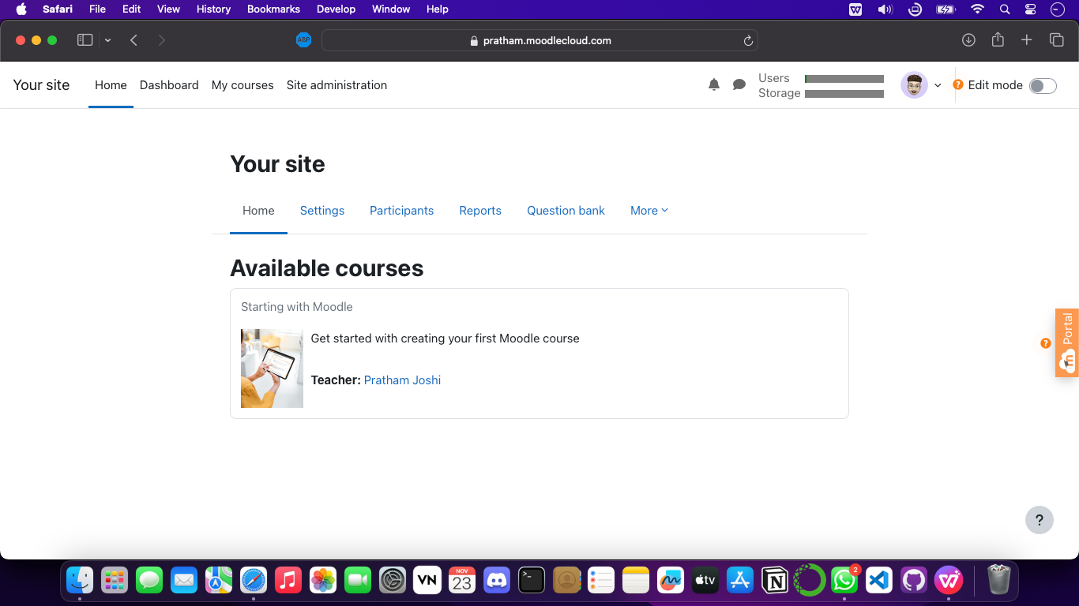

**Step 6 - Uplode Cource in MOODLE by Toggling the Edit option**

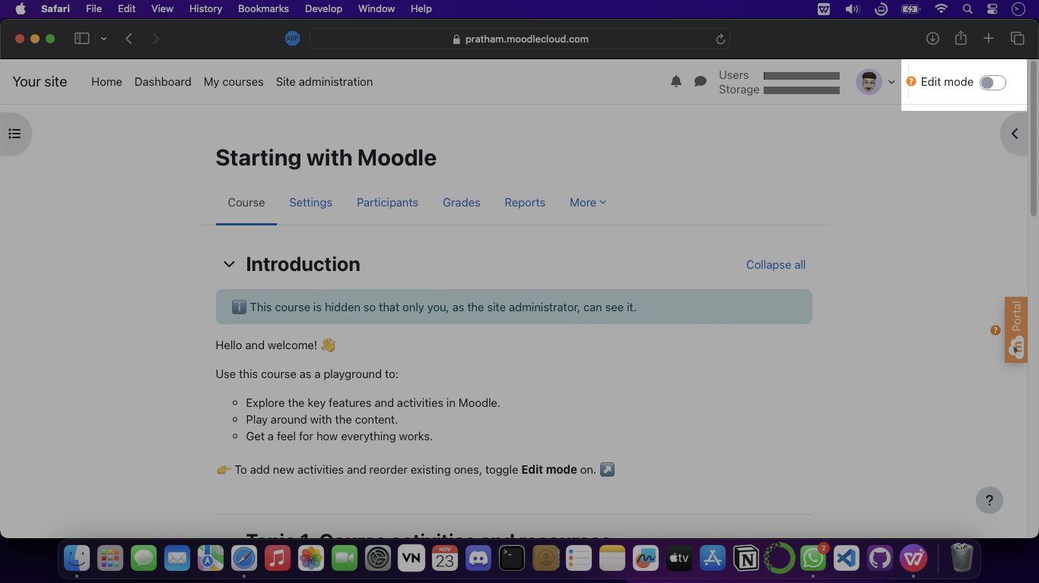

**Step 7 - After Editing the site, we can procide to make our site live from Site administration tab**

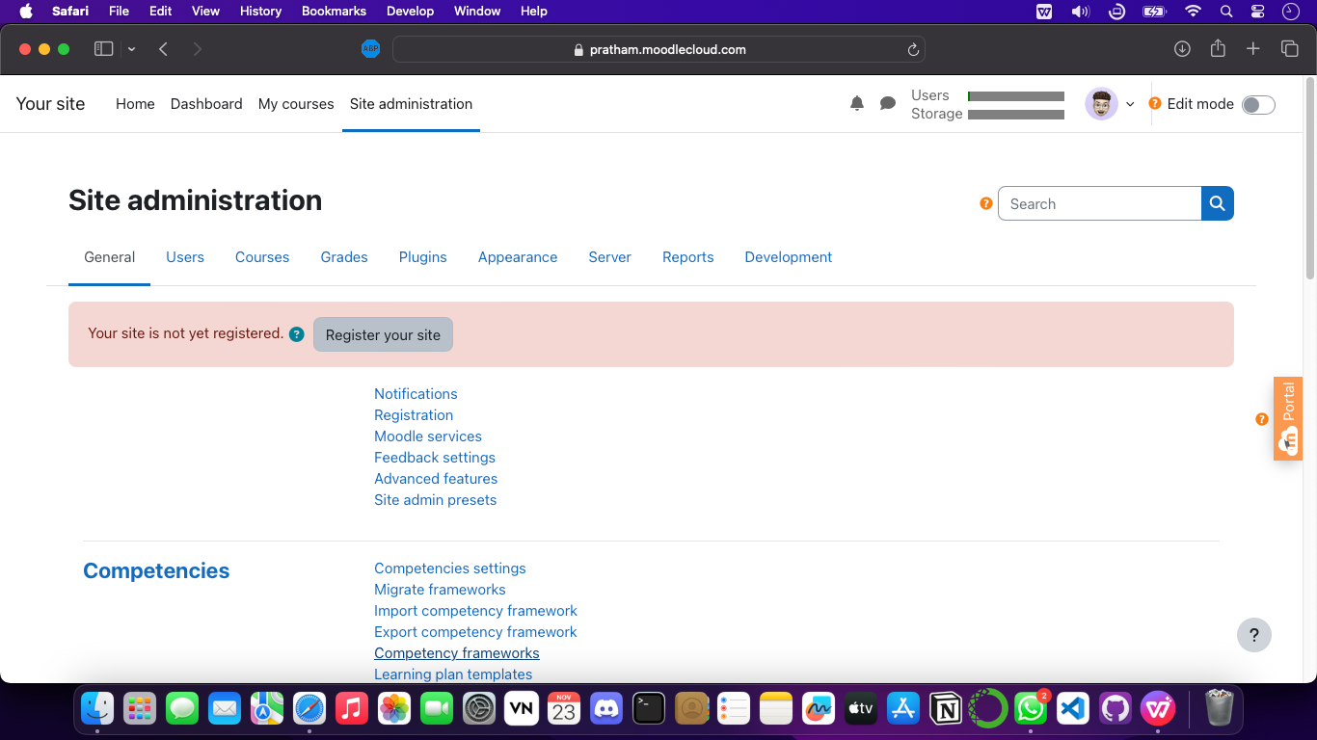

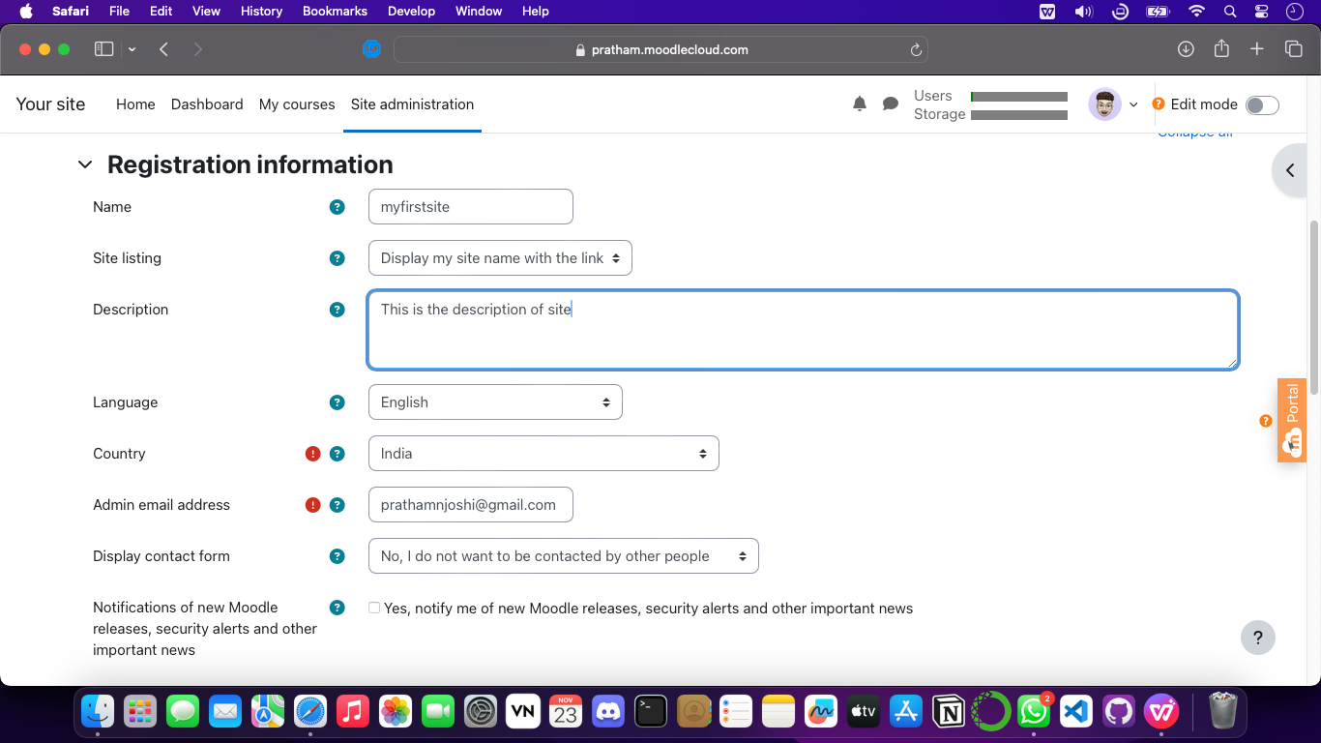

**Step 8 - Register your site after providing nessacary info.**

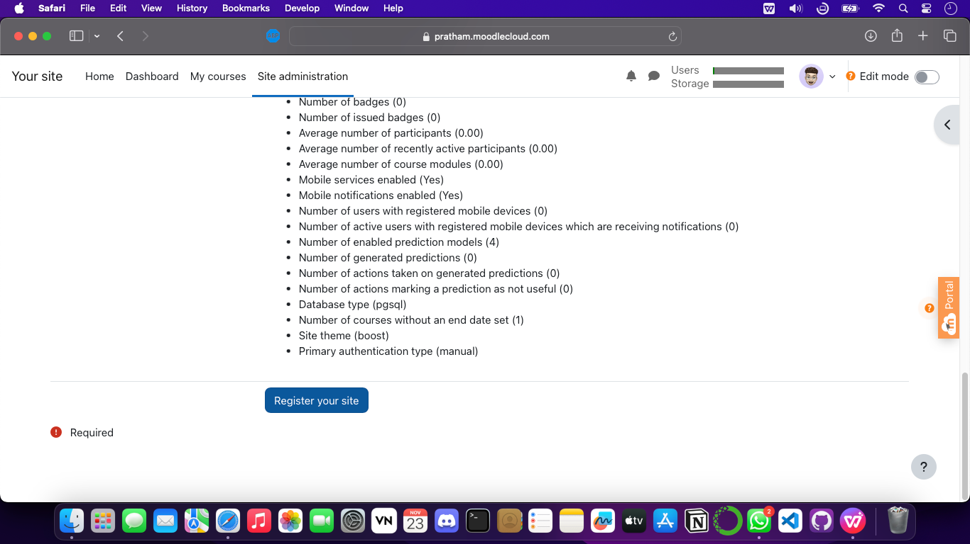

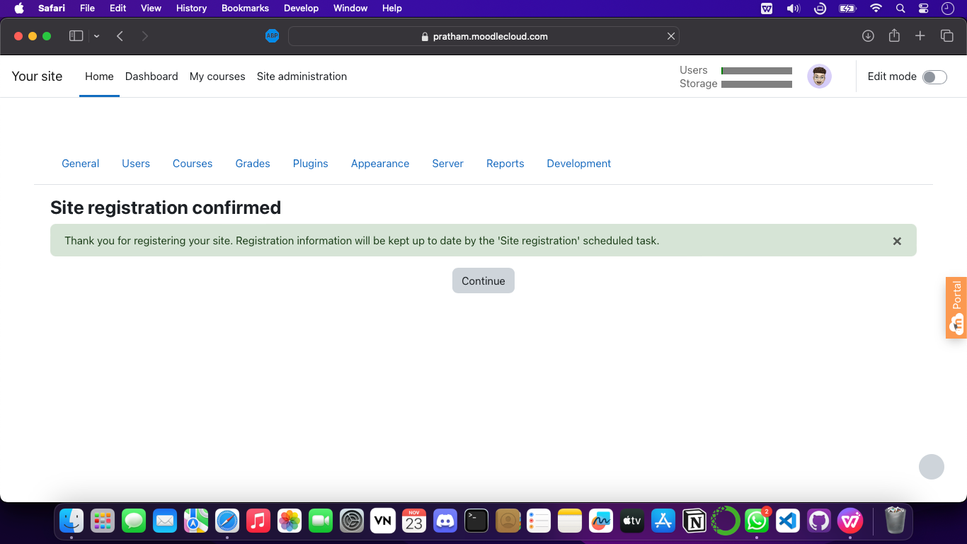

**STEP 9 - Successfully created and uploaded courses in moodle cloud now we can enrol the user for the moodle site**

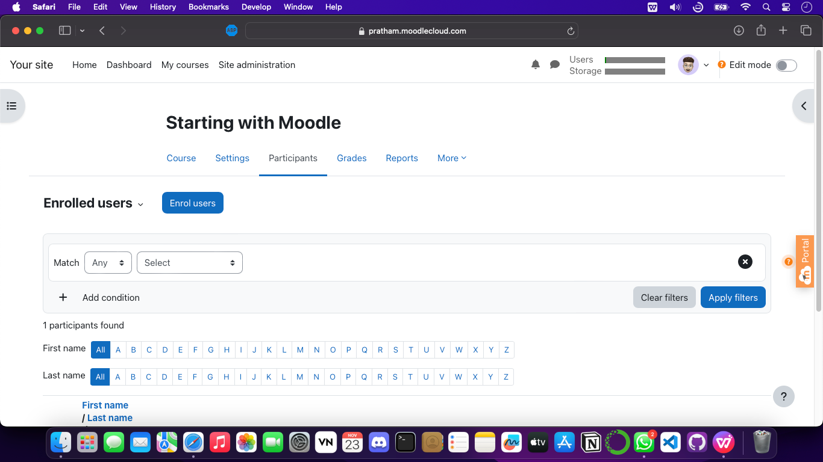

Created a LMS for Cloud Computing files for students to download

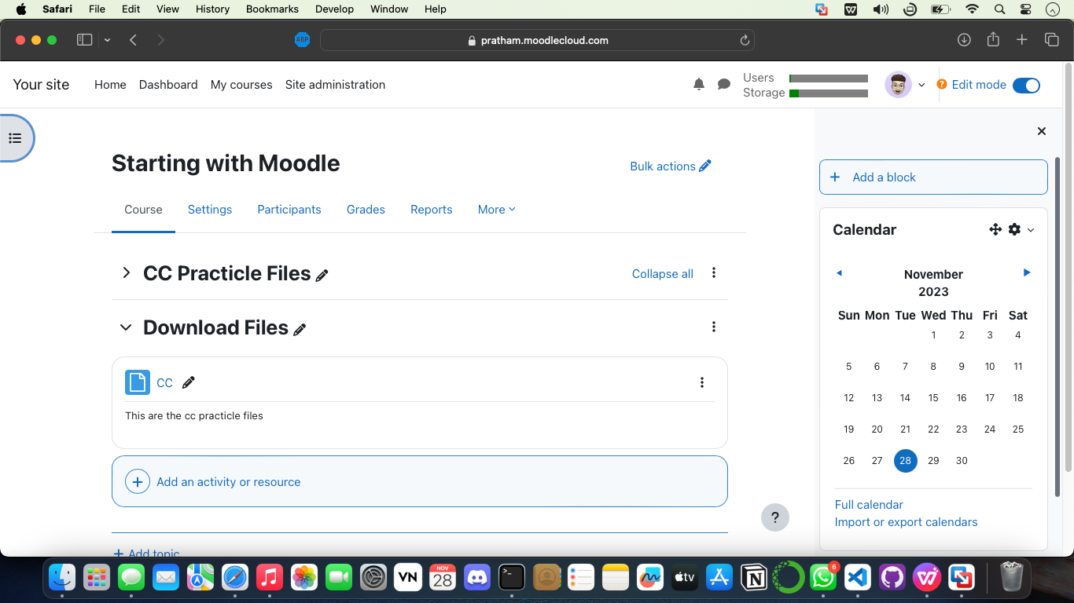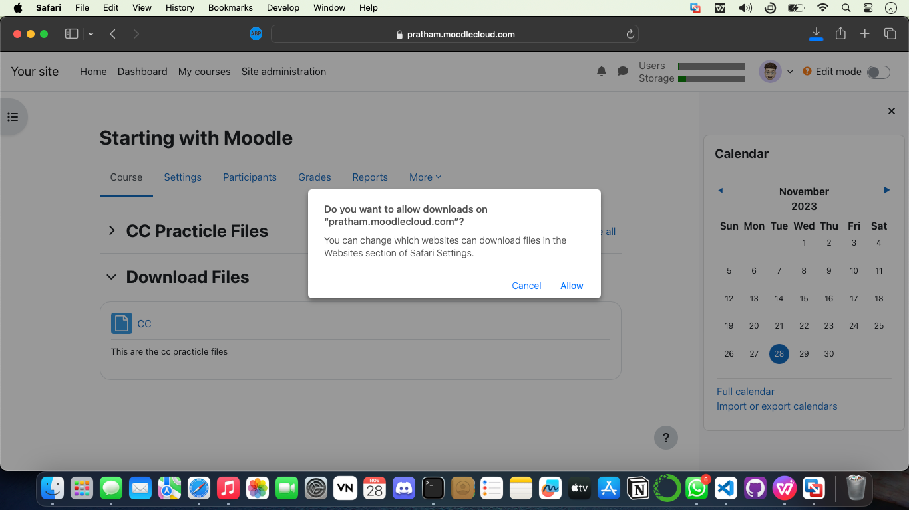

From now on, it's necessary to enroll your website, include users, and incorporate courses. Registered users with a username and password can access courses globally.

During a 7-day trial, courses are open to registered users.

If you wish to continue afterward, payment will be based on usage—number of users and space used for course materials.

**Conclusion**

Through the Moodle Cloud's free trial, we gained valuable insights into Software as a Service, setting the foundation for a deeper understanding of this innovative model.